**Topic: Convolution Neural Network (CNN)**

**Instructions**

Please share your answers filled inline in the word document. Submit Python code and R code files wherever applicable.

Please ensure you update all the details:

**Name:**

**Batch Id:**

**Topic: Convolution Neural Network.**

1. **Business Problem**
   1. **Objective**
   2. **Constraints (if any)**
2. **Work on each feature of the dataset to create a data dictionary as displayed in the below image:**

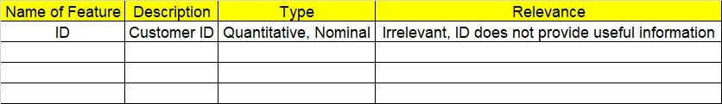

**2.1 Make a table as shown above and provide information about the features such as its Data type and its relevance to the model building, if not relevant provide reasons and provide description of the feature.**

**Using Python code perform:**

1. **Data Pre-processing**

**3.1 Data Cleaning, Feature Engineering, etc.**

**3.2 Outlier Imputation if applicable**

1. **Model Building**
   1. **Build the convolution neural network model**
   2. **Train and Test the data**
   3. **Briefly explain the model output in the documentation**



1. **Share the benefits/impact of the solution - how or in what way the business (client) gets benefit from the solution provided**
2. **Use Tensorflow for this assignment depending on your system configuration either tensorflowgpu or tensorflowcpu version.**

# Note:

**The assignment should be submitted in the following format:**

* **Python code**
* **Code Modularization should be maintained**
* **Documentation of the model building (elaborating on steps mentioned above)**

**Standard Grading Guideline :**

Grade A: All assignments submitted correctly on Time (with all mentioned content like: python code, r code, documentation)

Grade B: All assignments submitted but post the due date. Or Partial assignments are submitted.

Grade C and Grade D: Partial assignments submitted with incorrect answers, or worked on only R or Python or not all the content is submitted.

Grade F: Partial assignments submitted with incorrect answers and not all the content is submitted.

**Problem Statement: -**

1. Build a CNN model on CIFAR-10 dataset by applying few regularization techniques like drop out and data augmentation

2. Find out the differences between Convnet filter and the Maxpool layers

3. If the input of an image is 64x64x3 which has been convolved by 10 5x5 filters with stride 1 and padding 2.

a.How many activation maps are obtained?

b.What is the size of the activation maps?

c.How many parameters are calculated?

4. During training, I get into overfitting issues. What are the different techniques will you apply to overcome this issue and why?